**National Training**

**on**

**Microbial Identification and Diversity Analyses: Gene to Genome based Approaches**

**5th to 12th February, 2025**

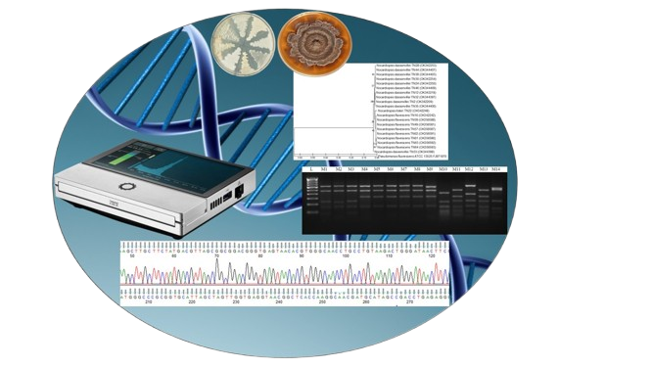

**Course Director**

Dr. Alok Kumar Srivastava, Director

**Course Coordinator**

Dr. Jyotsana Tilgam, Scientist

Dr. Shobit Thapa, Scientist

Dr. Kumar M, Senior Scientist

Dr. Hillol Chakdar, Senior Scientist

**ICAR-National Bureau of Agriculturally Important Microorganisms**

(ISO 9001:2008 Certified Institute)

**Kushmaur, Maunath Bhanjan-275103**

**Uttar Pradesh, India**

Email id: director.nbaim@icar.gov.in

Website: www.nbaim.icar.gov.in

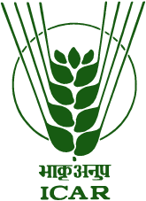

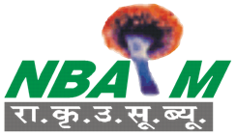

**About the training Program**

Microorganisms are essential components of ecosystems, playing critical roles in nutrient cycling, soil fertility, and plant health. The ability to identify and analyse microbial diversity is crucial for advancing agricultural productivity and ecological sustainability. With the advent of molecular tools, the scope of microbial research has expanded significantly, allowing for precise identification, characterization, and genome-level analyses of bacteria, cyanobacteria, and fungi. The training program on “Microbial Identification and Diversity Analyses: Gene to Genome Based Approaches” aims to equip participants with cutting-edge methodologies and practical skills in molecular microbial studies. This training is designed to benefit early-career researchers, scientists, and academicians working in biological sciences, equipping them with the tools and knowledge to contribute to advancements in microbial science and its applications in agriculture and allied fields.

**Themes**

* Molecular identification of bacteria, cyanobacteria and fungi
* DNA fingerprinting techniques
* DNA sequencing
* Sequence analyses and quality check
* Phylogenetic analyses
* Microbial genome sequencing

**Methodology**

The program will consist of a blend of lectures and practical sessions delivered by resource experts from ICAR-NBAIM and other renowned institutions. Emphasis will be placed on interactive and hands-on learning to ensure participants acquire the skills needed to conduct independent research in microbial identification and diversity studies.

**Expected benefits to the participants**

The participants will be sensitized with the current tools and techniques used in molecular identification of bacteria, cyanobacteria and fungi. Hands on practical sessions on DNA extraction, Primer designing, PCR, restriction analyses, Gene sequencing by Capillary sequencer, sequence analyses and quality check, phylogenetic analyses and Oxford Nanopore Technology for Microbial genome sequencing will enable the participants to undertake research in microbial identification and diversity.

**About NBAIM**

ICAR-NBAIM is one of the premier institutions of Indian Council of Agricultural Research (ICAR) leading research and development programs in the field of Agricultural Microbiology in India. The Bureau aims at collection, maintenance, conservation and utilization of agriculturally important microorganisms and their genomic resources for future needs. The Bureau is engaged in the cutting-edge research in Agricultural Microbiology, Microbial Biotechnology, Plant Pathology and Bioinformatics for the benefit of Indian agriculture and farmers. Human resource development is one of the important mandates of Bureau. The Bureau has organised several successful training programs on molecular microbial identification and characterization, molecular taxonomy, microbial diversity, biocontrol, plant-microbe interactions and the applications of bioinformatics in gene mining to benefit different stakeholders.

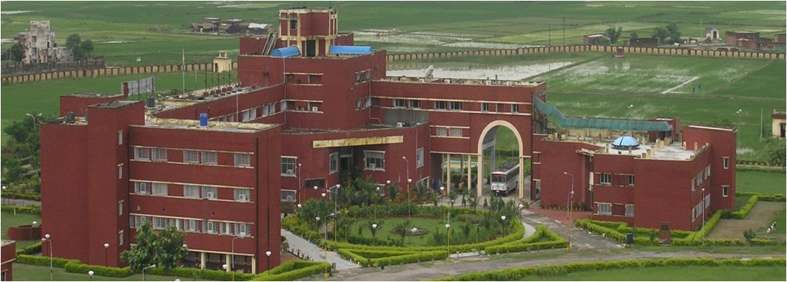

**Eligible participants**

M.Sc./Ph.D. students, Research Scholars, Post-Doctoral Fellows, Technical Officers, Scientists/Assistant Professors/Lecturers or above, from any University/ institute/ organization working in the area of biological sciences.

**Fees**

|  |  |
| --- | --- |
| Students/research scholars/post-doctoral fellows | Rs. 5000/- |
| Technical officers/ Scientists/Assistant Professors/Lecturers or above from Public/Private Universities or Govt. Institutions | Rs. 8000/- |
| Researchers from private or Non-Government organizations /Companies/ Firms | Rs. 12000/- |

**The fees include accommodation, food and training materials.**

**How to apply?**

Eligible participants should send the duly filled application form forwarded by the HoD/Head of the institution to the Director, ICAR-NBAIM to the email ids: [director.nbaim@icar.gov.in](mailto:director.nbaim@icar.gov.in) and [jyotsana.tilgam@icar.gov.in](mailto:jyotsana.tilgam@icar.gov.in).

***The Extended last date to apply for the training is 10th January, 2025.***

* The number of seats are limited to 20 participants
* The selected candidates will be notified by email on 11th January, 2025
* For any queries please contact:

8505909660 (Dr. Jyotsana)

9810910799 (Dr. Shobit)