Application format for participants
(A duly filled application form to be sent)
- Full name (In block letters): ………………………………………………………….…………….
- Designation: ……………………………………………………………………………….…………….
- Address of correspondence: ………………………………………………………….………..
- E-mail ID: ………………………………………………………….………………………….…………….
- Mobile no.: ………………………………………………………….……………………..…………….
- Date of birth: ………………………………………………………….………………….…………….
- Gender: ………………………………………………………….…………………………..……………
- Working experience: ………………………………………………………….…………………….
- Details of previous training
Programme availed, if any: ………………………………………………………….…………..

- Academic Details:
Examination | Subject/Discipline | Year of passing | Grade/percent | University/  institution
Graduation
Post graduation
Ph.D.
others

Date:
Place: Signature of applicant

Recommendation of forwarding authority

Name and Designation:

Address :
Date: Signature and seal

Training Programme
On
Techniques in Microbiology

5-18th November, 2016
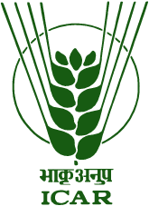

ICAR-National Bureau of Agriculturally Important Microorganisms
Kushmaur, Maunath Bhanjan-275103, UP, India

Course coordinator
Sanjay Kumar Goswami
Course Co-Coordinators
Drs. Hillol Chakdar, Kumar M and Arjun Singh

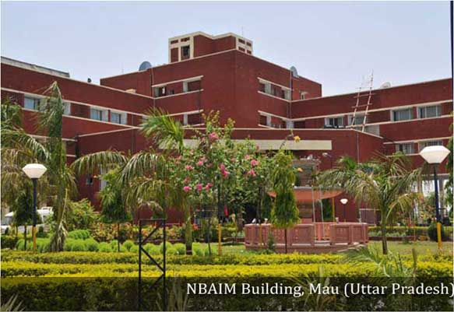
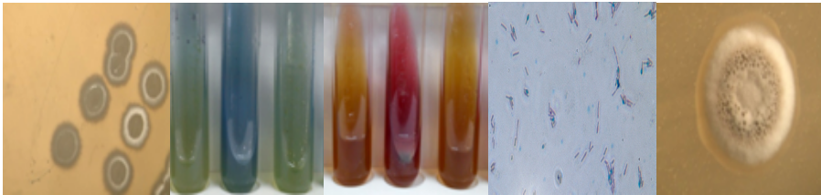

Background
Microorganisms are ubiquitous in nature and essential component of all ecosystems. They play an active role in soil health and fertility due to their involvement in biogeochemical cycles. Healthy and fertile soil is the most important factor for sustainable crop production. Due to their tremendous metabolic potential and extensive adaptability, microorganisms have found multifarious application in agriculture. However isolation, characterization and evaluation of microorganisms remain the prerequisite before they find their application. Due to their metabolic diversity, microorganisms require different isolation procedure and may even require special facilities. For characterization and identification of isolated microorganisms a set of biochemical tests and molecular techniques are followed. Practicing such techniques require sound knowledge of microbiology and technical perfection.
Course outline

The training is divided into three parts-
- Methods of sampling, media preparation and isolation of microorganisms
- Microscopy and identification of the microorganisms
- Characterization of microorganisms
These three aspects will cover the topics like sampling methods, media preparation for cultivation of different groups of microorganisms, isolation of microorganisms e.g. fungi, bacteria, actinomycetes and cyanobacteria from soil and Rhizobium from nodules; enumeration of viable cell count of microorganisms by standard plate count method or MPN technique; enumeration of total cell count of microorganisms by measurement of optical density or protein content; purification, maintenance and preservation of microbes; biochemical and physiological characterization; staining and microscopy; Scanning Electron Microscopy (SEM); characterization of microorganisms for functional attributes; molecular characterization of microorganisms; techniques for field evaluation of microorganisms; Intellectual Property Rights (IPR); biosafety.
Who can apply?
This training programme is open for technical personnel working in different ICAR institutes. The total number of seats will be limited to 20 (Twenty) only.

How to apply
Eligible and interested participants are requested to send their application in the prescribed format duly nominated by the competent authority to the Director, ICAR-NBAIM and course coordinator on or before the last date by email, fax or post. The participants will be selected on the basis of their qualifications and professional experience relevant to the training course.
TA/DA, boarding and Lodging
The training expenditures like TA/DA, accommodation charges, food charges including breakfast, evening tea, and dinner has to be borne by the sponsoring institute of the participants (As per office MO. No. 4-10/2016-HRM/157 dated 13th May 2016). Bills for food and stay at ICAR-NBAIM will be provided to the participants to get claim from respective institutes. ICAR-NBAIM will provide only session tea, working lunch, study material and registration kit. Participants are requested not to bring their families along with them as the guest house facility available here is limited.
Important Dates
Last date for receipt of application- 20th August, 2016
List of selected candidates will be announced on 24thAugust, 2016
Correspondence: All correspondence should be addressed to Director, ICAR-NBAIM/ Course Coordinator
Course Coordinator
Sanjay Kumar Goswami
Scientist, ICAR-NBAIM, Kushmaur, Maunath Bhanjan- 275103, UP, India
Tel. (O) 91-0547-2530156 (Direct), E-mail: sanjaygoswami65@gmail.com
Mobile: 09455936742

Course Director
Dr. Anil Kumar Saxena
Director
ICAR-National Bureau of Agriculturally Important Microorganisms
Kushmaur, Maunath Bhanjan- 275103, UP, India
Tel.91-0547-2530358, Fax: 91-0547-2530381, E-mail: nbaimicar@gmail.com
The information brochure cum application form is also available on ICAR-NBAIM website: www.nbaim.org.in ,www.mgrportal.org.in

