ICAR-National Bureau of Agriculturally Important Microorganisms (NBAIM)
Understanding and conserving our national heritage of agriculturally important microorganisms
National Training on
Advanced techniques for selection of potent strains for biofertilizer production, quality assessment and application
18th to 25th September 2024
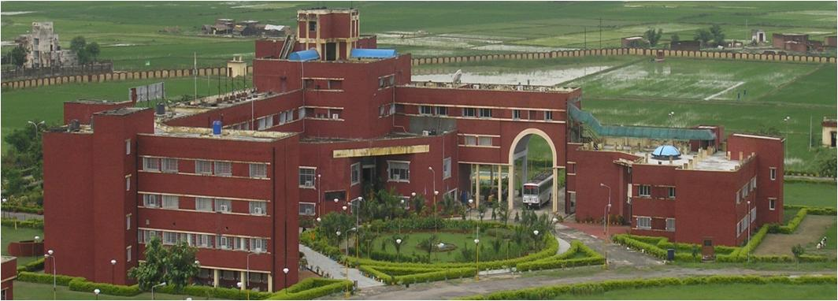
About NBAIM
ICAR-NBAIM stands as a prominent institution under the Indian Council of Agricultural Research, spearheading research and development initiatives in the realm of Agricultural Microbiology within India. The Bureau is dedicated to the collection, preservation, and utilization of agriculturally significant microorganisms and their genetic assets, poised to meet future demands. With cutting-edge research capabilities, the Bureau is committed to advancing Agricultural Microbiology, Microbial Biotechnology, Plant Pathology, and Bioinformatics, with the goal of benefiting Indian agriculture and its farming community.
In addition to its core research pursuits, human resource development constitutes a pivotal aspect of the Bureau's mission. Over time, the Bureau has successfully orchestrated numerous training programs encompassing various facets of fundamental and applied sciences, designed to serve a diverse spectrum of stakeholders. These training endeavours encompass national programs spanning topics; molecular microbial identification, characterization, molecular taxonomy, biocontrol, plant-microbe interactions, and the bioinformatics. These initiatives have been consistently conducted since the inception of the Bureau, reinforcing its commitment to fostering knowledge dissemination and skill development in the field of Agricultural Microbiology.

Salient features of the training
- Qualitative and quantitative assays for identifying potent biofertilizer strains
- Different delivery methods for biofertilizers
- Quality assessment of different formulations of biofertilizers
- Regulations on Biofertilizers and Microbial biostimulants
The training programme will include both lectures and practical sessions on the above thematic areas. Resource experts from the Bureau and other reputed institutes will address the participants. Emphasis will be given to hands on training and exposure to tools and techniques used in selection of potent strains, formulation development and quality assessment.
Expected benefits to the participants
The participants will be sensitized with the current tools and techniques used in selection of potential strains for biofertilizers, delivery methods, formulation development, quality assessment and relevant regulations. Hands on practical sessions on will enable the participants to undertake research in strain development to quality assessment or set up bioformulation production units.
Eligible participants and Fees
Ph.D. Scholars, Research Scholars, Post-Doctoral Fellows, M. Sc., Students | Rs. 5000
Technical officers, Scientists/Assistant Professors/Lecturers from SAUs/ICAR/CSIR/UGC and other public/private universities | Rs. 8000
Researchers from private or non-Government organizations /Companies/ Firms | Rs. 12000
How to apply?
Eligible participants may fill the attached application form and send to the Director, ICAR-NBAIM with a copy to Dr. Kumar M, Senior Scientist, ICAR-NBAIM on/or before 29th August 2024.
Contact
Director ICAR – NBAIM: director.nbaim@icar.gov.in
Dr. Kumar M: kumarmic84@gmail.com

The selected candidates will be notified on 2nd September 2024
Organizing Team
Course Director | : Dr. Alok Kumar Srivastava, Director
Course Coordinators | : Dr. Kumar M, Senior Scientist
 | : Dr. Hillol Chakdar, Senior Scientist
 | : Dr. Shobit Thapa, Scientist

ICAR-National Bureau of Agriculturally Important Microorganisms

Kushmaur, Maunath Bhanjan-275103

Uttar Pradesh, India
Tel.: +91-547-2970733,
Website: www.nbaim.icar.gov.in; www.mgrportal.org.in

National Training on
Advanced techniques for selection of potent strains for biofertilizer production, Quality assessment and application
18th to 25th September 2024
ICAR- National Bureau of Agriculturally Important Microorganisms (NBAIM), Kushmaur, Maunath Bhanjan, Uttar Pradesh- 275101

APPLICATION FORM

Personal Details
Name :
Gender :
Designation/Occupation :
E-mail :
Mobile Number (s)
(Preferably WhatsApp number) :

Contact Details
Full Address :
City & State :

Academic Details
Degree (M.Sc./M.Phil. /Ph.D.) :
Subject Specialization :
College/Department :
University/Institute :

Accommodation Required :
(Yes / No)

Registration fees (Tick whichever is applicable)
Ph.D. Scholars, Research Scholars, Post-Doctoral Fellows, M. Sc., Students | Rs. 5000
Technical officers, Scientists/Assistant Professors/Lecturers from SAUs/ICAR/CSIR/UGC and other public/private universities | Rs. 8000
Researchers from private or non-Government organizations /Companies/ Firms | Rs. 12000

……………………………..
Signature of the Applicant

