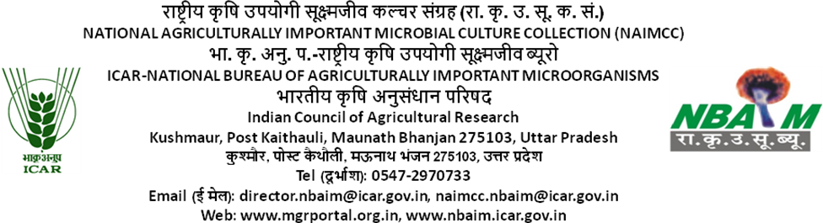

Passport Data for Submission of Microbial Culture(s)

Name of depositor(s):
Designation:
Address:
Phone/Fax:
E-mail:

Microorganism’s details
Name of microorganism (with isolate/strains/race
/biotype etc.)
Type of microorganism  (Please Tick) √ | Fungus | Bacterium | Actinomycetes | Cyanobacterium | Other (please specify)

Isolation details
Source of isolation  (Please Tick) √ | Plant | Soil | Water
Source of isolation  (Please Tick) √ | Animal | Insect | Brackish | Freshwater | Marine
Source of isolation  (Please Tick) √ | Any other, please specify
Name of host; Variety (if known)
Isolated from which part
Isolated by with date

Geographical origin
Longitude & latitude
Place/village
District
State

Growth and maintenance
Media
Temperature
Incubation time
Sub-culturing period
Special requirement for growth and sporulation, if any
Light Intensity*
Light duration*
pH
Other if any
*Required only for cyanobacteria
Identification details
Morphological description  Image (Colony photograph is mandatory in case of bacteria, fungi, actinomycetes; for cyanobacteria please provide clear microphotographs showing morphological features like veg. cells, heterocysts, akinetes, hormogonia etc. ) | Insert image
Taxonomical reference used for identification
Any typical biochemical character, if known
Molecular description (with NCBI/EMBL/DDBJ accession number is essential) | Insert image, If any & sequence if possible
Unique marker, if any
Identified by

Economic importance (provide details in the form of publication, if any)
Agricultural
Industrial
Medicinal
Biotechnological
Pathogenic
(virulence/aggressiveness)
Other (if any)

Other
Deposited in form of
Provide accession number, if culture deposited elsewhere
Publication involving the strain (if any)
Any risk associated with the culture
IPR/Patent information, if any
Culture deposited as | Safe Deposit
Signature and date

General Guidelines

- Cultures deposited under ‘Safe Deposit’ will not be distributed to others/third party.
- Safe Deposition is an annual culture maintenance service and the fee has to be paid every year.
- Upon non-submission of annual maintenance fee, the accessioned culture(s) will be removed from “Safe Deposition” and will be included in “General Deposition” and will be available to other stakeholders
- Attach separate culture passport data sheet for each isolate.
- Tick appropriate box in passport data sheets.
- Attach separate sheet, if necessary.
- Depositor is required to submit final hard as well as soft copies of duly signed passport data sheet (s) along with the culture(s).
- For any further query, kindly contact In-charge NAIMCC, Email: naimcc.nbaim@icar.gov.in, you can also visit our website www.nbaim.icar.gov.in and www.mgrportal.org.in.
- Depositor is required to read “Guidelines for Designated Repositories” notified by National Biodiversity Authority, Chennai (www.nbaindia.org.in) for detailed information about deposition of novel taxa of microorganisms in Designated Repository.

