**Workshop on “Interfacing Innovation and IPR for Licensing and Commercialization of Technology in the Changing Global Scenario with special reference to microbial genetic resources”**

A three days workshop on “**Interfacing Innovation and IPR for Licensing and Commercialization of Technology in the Changing Global Scenario with special reference to microbial genetic resources**” was organized at ICAR- NBAIM, Mau from 18-20th Dec., 2014 as an activity under ICAR plan scheme “Intellectual Property Management/Commercialization of Agriculture Technology”. Dr. Renu, Senior Scientist cum ITMU, Member Secretary, NBAIM assisted by Dr Pawan Kumar Sharma, Principal Scientist; Dr K Pandyian, Scientist and Mr. Udai B. Singh were workshop coordinators. In total there are 20 registered participants as listed below:

1. **Dr. Senthil Kumar** Senior Scientist, IIPR, Kanpur.
2. **Dr. Satheesha Avunje** Scientist, CIBA, Chennai
3. **Dr. Jitendra Kumar** Research Associate, DSR, Mau
4. **Sh. K. Ahamed Basha** Scientist, CIFT, Cochin
5. **Sh. Ashutosh Kumar** Senior Research Fellow, DSR, Mau
6. **Dr. Hillol Chakdar** Scientist, NBAIM, Mau
7. **Dr. Rajiv Singh** Senior Scientist, DSR, Mau
8. **Dr. Kumar M.** Scientist, NBAIM, Mau.
9. **Sh. Pramod K. Sahu** Scientist, NBAIM, Mau
10. **Dr. Dipak T. Nagrale** Scientist, NBAIM, Mau
11. **Sh. A. K. Singh** Guest Faculty, Dept. of Forestry, CSA Univ. Kanpur
12. **Dr. N. Karthikeyan** Scientist, NBAIM, Mau
13. **Dr. Roshan Kumar** Research Associate, NBAIM, Mau
14. **Sh. Sandeep Saini** Research Associate, NBAIM, Mau.
15. **Ms. Megha Singh** Senior Research Fellow, NBAIM, Mau
16. **Ms. Ankita Verma** Senior Research Fellow, NBAIM, Mau
17. **Ms. Upasana Sahu** Senior Research Fellow, NBAIM, Mau
18. **Ms. Deepti Malviya** Senior Research Fellow, NBAIM, Mau
19. **Ms. Amrita Gupta** Senior Research Fellow, NBAIM, Mau
20. **Sh. Wasiullah** Senior Research Fellow, NBAIM, Mau

Beside this scientific, technical and administrative staff of NBAIM also attended the workshop.

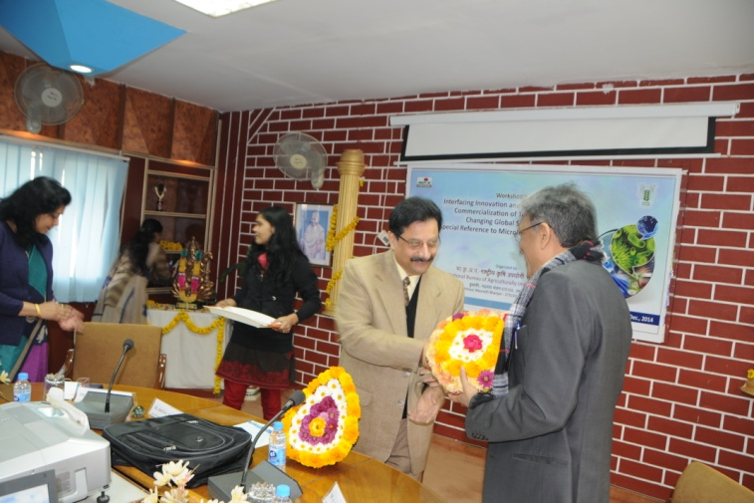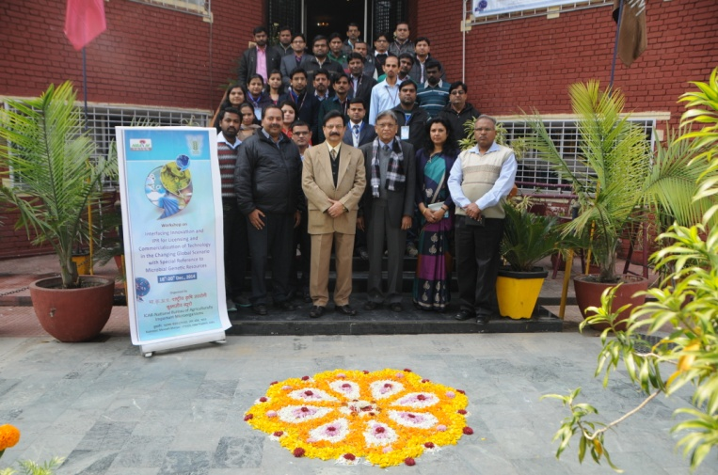

Three days long activity of workshop was divided into an inaugural session, three technical sessions, two hands on practical exercise sessions and a plenary session. The first day activity included inaugural session coordinated by Dr. P.K. Sharma, started with the address by Dr. A. K. Sharma, Director NBAIM who welcomed Expert Guest Sh. R. Saha, Former Advisor, DST & Ex Director, PFC, TIFAC, GOI and Trainee participants. He stressed on the need to have awareness about technical details on protection of intellectual property and maximizing its usage through commercialization of technologies in the current global scenario. Dr. Alok Kumar Srivastava, Senior Scientist, NBAIM gave a brief about activities of NBAIM, its developmental stages, activities and achievements. Dr. Renu, workshop coordinator, gave brief on concept and objectives of due workshop and importance to bridge the knowledge gap on IP issues among researchers/innovators from applied point of view. A Technical Bulletin on “Intellectual Property Rights: Facts and Procedure in India” published by Director, NBAIM alongwith informative brochures on IPR were distributed alongwith the workshop kit. Dr. K Panidiyan, Scientist, NBAIM proposed vote of thanks.

Lead lecture on “**Overview of IPR- current scenario**” was presented by Sh. R Saha who gave a very detailed insight into various forms of intellectual property rights with examples and various acts pertaining to it in India.

Post lunch Technical Session 1 was chaired by Sh R Saha and rapporteur of the session was Dr K. Pandiyan. Dr P.K. Sharma, Principal Scientist, NBAIM gave lecture on “**Patenting of Microbes**”. He highlighted the historical development in patenting of microbes and microbiological process and comparison of patenting laws in different countries alongwith India. Shri. R. Saha elaborated on “**Valuation of patents**” explaining how to calculate cost of the patent by innovator. Mr Swapnil Gawande, Legal Advisor (IPR), Amrawati gave lecture on “Introduction to Intellectual property rights, application filing and procedure”.

The second day (19.12.2014) activities of the workshop started with the Technical session 2 in forenoon chaired by Dr A.K. Sharma, Director, NBAIM and Dr P.K. Sharma, Principal Scientist, NBAIM acted as rapporteur. Sh. R Saha gave lecture on **Fundamentals of licensing of IPR and negotiations** in which he explained that concept of licensing, their types in terms of intellectual property rights and negotiations between the licensing parties. Dr D. K. Aggarwal, Principal Scientist from Directorate of Seed Research, Mau gave insight into the activities of **PPV&FR** Authority and important highlights of the Act. This was followed by presentation of Dr Sujit Kumar Scientific Officer (Plant Breeding), U.P. Council of Agricultural Research (UPCAR), Lucknow on **Present status of IP related issues in Uttar Pradesh.** He gave recent pictures on various forms of IP registered from Uttar Pradesh.

The afternoon session on the second day was introduction of **Drafting and filing of patent applications with practical exercise.** The whole afternoon was devoted to hands on exercises given to the participants and the session was moderated byMr Swapnil Gawande, Legal Advisor (IPR), Amrawati and **Mr Tushar Chauhan,** Solution Advisor, Amrawati.

The third and last day started with the Hands on session with the introductory lecture on **Types of CLAIMS and drafting of claims in patent specification by** Mr Swapnil Gawande followed by practical exercises on the subject by Mr Swapnil Gawande and Mr Tushar Chauhan Amrawati.

This was followed by technical session 3 in which Dr Sushil Kumar Sharma**,** Principal Scientist and I/c NAIMCC, ICAR- NBAIM, Mau gave lecture on “**Registration of microbial germplasm”** in which he explained the role of NAIMCC as the registering body at NBAIM. Dr Renu, Senior Scientist cum Member Secretary ITMC gave insight into **Intellectual Property Management System in ICAR** in which how various forms of IP generated through researches conducted in ICAR are managed, protected and maintained in the system alongwith the introduction on extended commercial venture of ICAR, Agriinovate India Limited.

All the lectures and practical sessions had active discussions and participation from audience end.

Plenary session was chaired by Dr. A. K. Sharma, Director, NBAIM.Discussion and briefings were done by experts and participants. Dr Renu presented the workshop report. Enthusiastic response from various participants like Dr. Satheesha Avunje,CIBA, Chennai;Sh. K. Ahamed Basha**,** Scientist, CIFT, Cochin Sh A. K. Singh, CSAUA&T, Kanpur; Mr Parmod Sahu, Scientist, NBAIM and Ms Ankita Tiwari, SRF, NBAIM was there. All the participants felt that the uniqueness in this workshop was that each day few hours were solely devoted to practical sessions in which all the participants actively participated and clarified their doubts.

Distribution of Certificates was done by Dr. Arun K Sharma. Concluding remarks were given by chairman of Plenary Session, Dr. A. K. Sharma who felt after receiving response from participants that such a kind of workshop where amalgamation of lectures with practicals is there is more successful in serving its purpose and is much required. The workshop was concluded by vote of thanks from Dr. P.K. Sharma. Three days events of workshop were well covered by press and electronic media.

